Get your password and sign in
Your password will be sent by email. The email will contain the website, login ID, and temporary password to use when you sign in the first time. Sign in at the Resident sign in box on the right side of the screen.
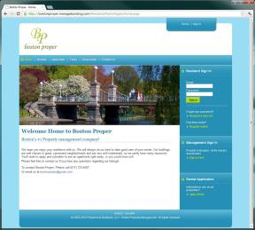
You will be prompted to change your password the first time you sign in.
Home tab
The Home tab is the first page you will see when you log in. This page grants immediate access to the things that matter most: announcements of upcoming events, your current balance, and shared files.
You can use the My Info page to keep your contact information up-to-date and to change your password.
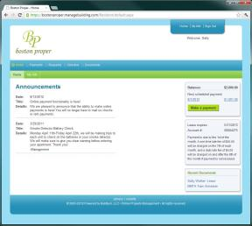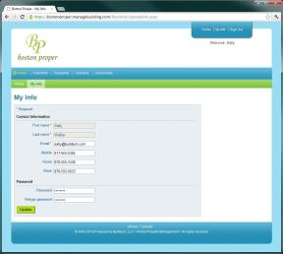

Payments tab
The Payments tab shows ledger history - charges, payments, refunds, and so on.
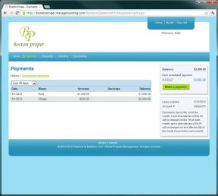
Make a payment online by clicking the Make Payment button. You have the option to make a one time payment or set up an automatic payment to process on a regular basis.
Once you make a payment, it will be credited to your account in three days. Please make your online payment by the 2nd to avoid a late fee.
It may take a day or two for the charge to affect your bank account or credit card. If an online payment is refused by your bank, the Payments tab will be updated automatically.
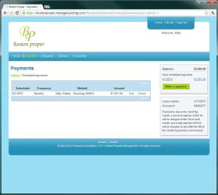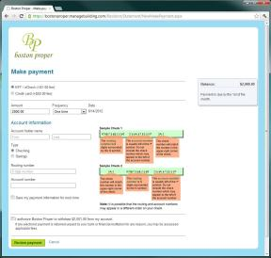

Requests tab
The Requests tab allows for the submission of maintenance requests. To add a request, come to this page, click submit a request and complete the form.
Once submitted, your request is saved and available here. When we update your request, we'll let you know by email and on this page.
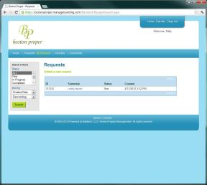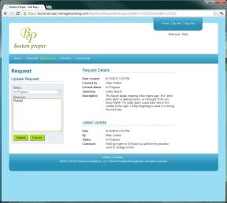
Directory tab
The Important Numbers page helps you find your way in your new neighborhood. You will find phone numbers and websites for local utilities, municipal services, yummy restaurants, and other useful stuff.
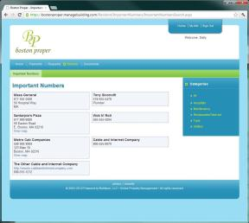

Documents tab
The Documents tab shows all files that have been shared with you. For example, you might find a scanned copy of your lease, move in report, and local maps of the area on this page.
